Monday July 20
at 4:00pm at the Parish House

Chebeague Steps Up

Welcomes
Dick Woodbury

Maine State Senate District 11
2010–2014

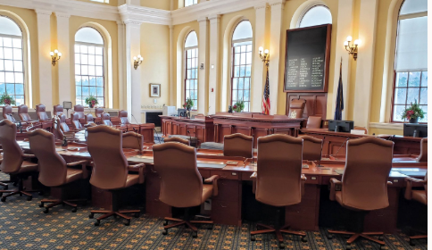
Partisanship or Collaboration?
Reflections from a Journey in
State Level Politics

Mr. Woodbury also worked for many years as an economist and program manager with the
National Bureau of Economic Research.

